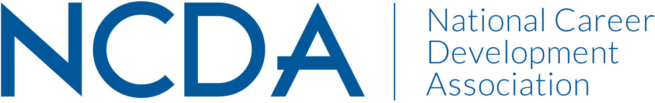

Annual/Mid-Year Report

NATIONAL CAREER DEVELOPMENT MONTH COMMITTEE
March 15, 2021
Committee Chair 2020-2021:
Morgan Ray, MA, CCC
Career Development Coach
Wake Technical Community College
Raleigh, NC
919-308-0768 / 336-539-1671
mbray@waketech.edu

Committee Members:

Delasia Rice delasiarice342@gmail.com
Shelli Farquharson smfarquharso@fcps.edu
Kelsey Hines khines1123@gmail.com
Lisa Fortes Lisa_Fortes@vrtx.com
Jennifer Cerda Jennifer.Cerda@sjcd.edu
Laura Lee feistykitty808@gmail.com
Mary Savoy-Lowrey mslowery@yahoo.com
Lorie Durant coffeemom7878@gmail.com

Committee Purpose:
This Committee coordinates a national brochure reflecting the importance of career development as a practical resource for professionals in promoting the concept of career development.

Activities to Date
- September and October, chair and co-chair duties transferred to Morgan Ray and Tovon Hamilton
- Announced the dates and deadlines of the local, state, and national submissions to the Poetry and Art Contest
- Advertised activities via social media and through state contacts
- Contest submissions currently being shipped from NCDA headquarters.

Projected Plan through fiscal year end (September 30th)
- Facilitate judging of poetry and art submissions tallied no later than mid – April.
- Notify all winners in Mid-April.
- Plan to share winner information with conference organizers.
- Explore methods to improve communications between chair and committee.
- Discuss plans to improve marketing with state contacts.
- Explore options to market for states that have no state contact or representation.
- Identify a new chair and co-chair for 2021-2022

