National Career Development Association
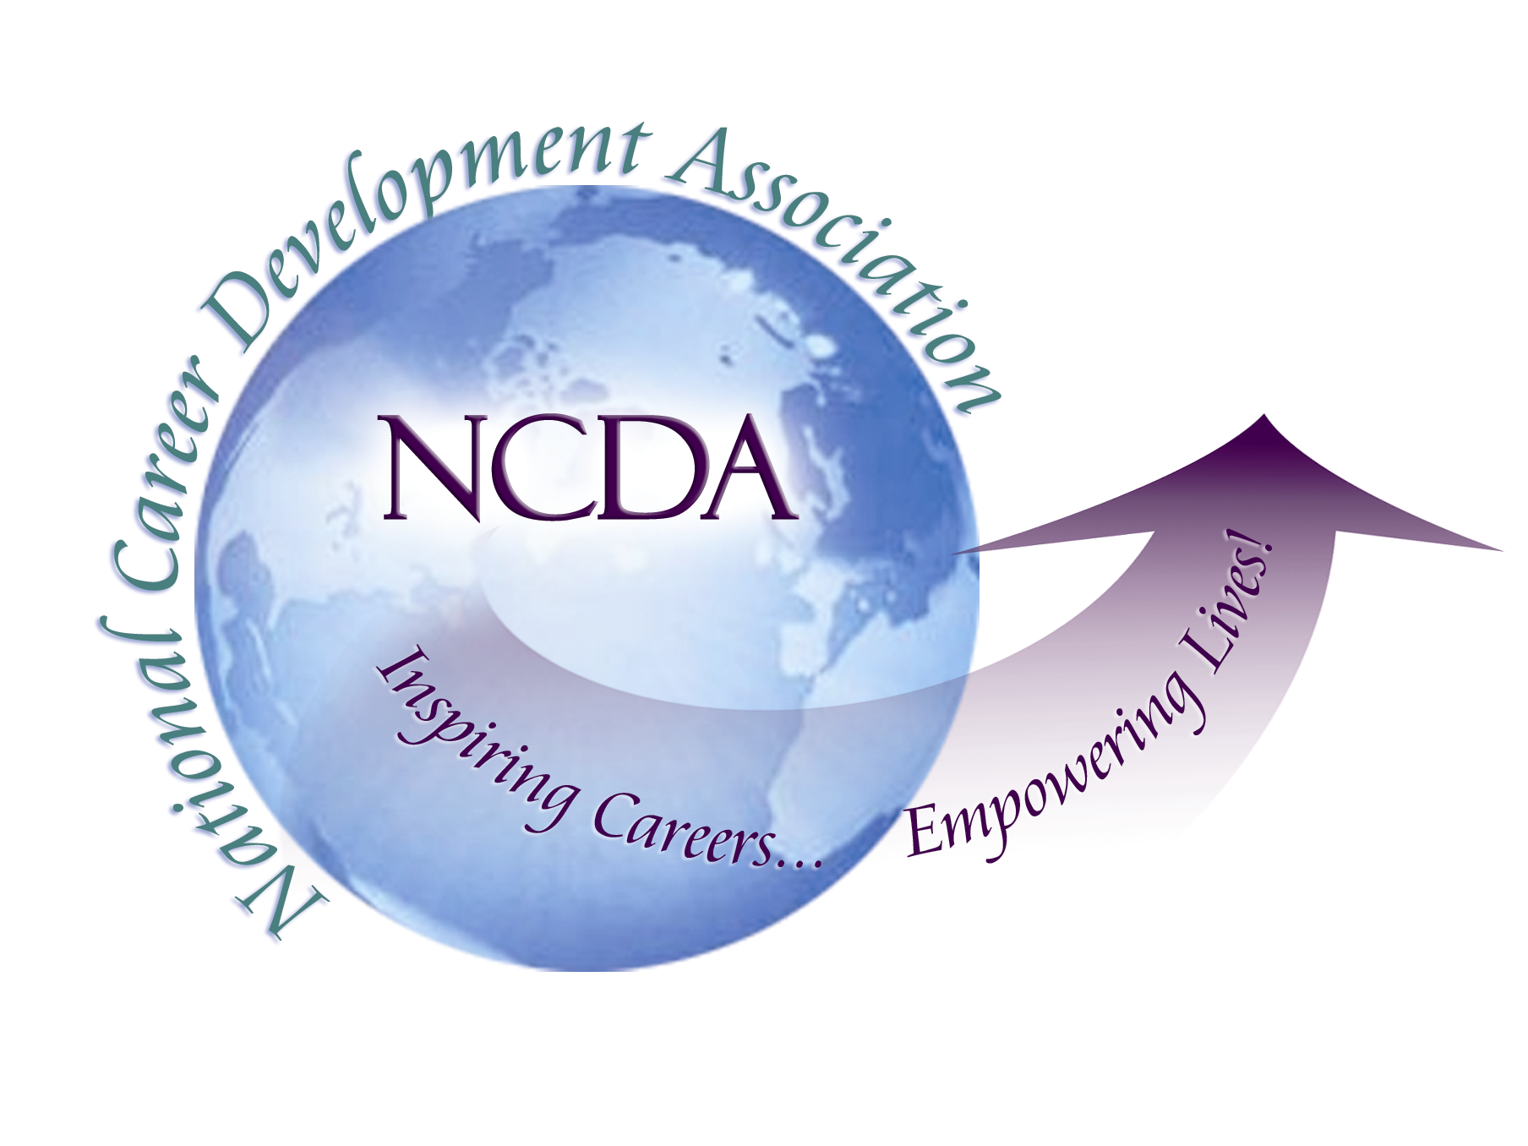
305 N. Beech Circle
Broken Arrow, OK 74012
918/663-7060
Fax: 918/663-7058
www.ncda.org

National Career Development Association
Leadership Academy
Project Summary

Participant(s): Amy Mazur and Pat Jennings

Board Mentor:

Leadership Academy Class: LA II, 2007-2008

Project Title: The Advocacy Imperative

Project Description:
We see ourselves as compassionate counselors concerned with the state of the worker today. Even though we are not experts in the area of advocacy, we feel a strong need to act so that all workers are treated with respect, dignity and fairness in the workplace, and that to make change, to collaborate with each other, to empower NCDA members, and to learn from experienced advocates in this area is THE ADVOCACY IMPERATIVE.

NCDA is well positioned to be a strong voice on behalf of the worker in today’s ever changing and complex work world.

We feel our voices will be stronger and heard more clearly if we speak as a collective voice, as members of a respected professional association with over 4000 members who know first-hand and who hear daily about the plight of the worker in today’s ever changing and complex work world.

We feel the current NCDA goal expressed by President Darrell Luzzo is directly aligned with our Action Learning Project goal of promoting advocacy in the career counseling profession.

And as Vong Ratts, Ph.D said in his July 2007 NCDA conference workshop, Career Counselors as Social Justice Advocates: Incorporating the ACA Competencies into Career Counseling, “ Because if we don’t…who will?”

Summary/Conclusion:
- Transformed our own career development practices
- Supported each other in our work
- Presented at local and national conferences
- Increased group membership and group visibility (articles)
- Partnered with organizations actively engaged with advocacy work

