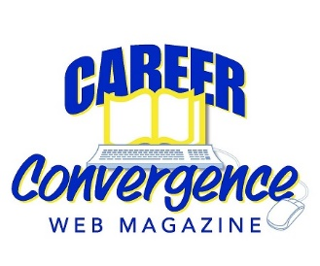
NCDA COMMITTEE MID YEAR REPORT

CAREER CONVERGENCE WEB MAGAZINE
March 15, 2020

Melanie Reinersman, Editor, webeditor@ncda.org

Associate Editors: Marty Apodaca, Abiola Dipeolu, Sarah McElroy, Cori Shaff, Billie Streufert, Michelle Tullier, Victoria Shivy
Field Editors: Vera Chapman, Mason Murphy, Willa Smith, Amy Thul-Sigler

Activities to Date

- Created new issues on Oct 1, Nov 1, Dec 1, Feb 1 and March 1, bringing the total issues up to 177 (since 2003)
- Published 6 new articles, plus one Tech Tip, each month. Electronic distribution to over 20,250 emails on the first of the month
- Recorded 30 day hit rate for each issue’s articles
- Welcomed a new Board liaison, Courtney Warnsman
- Held a conference call on Dec 9, 2019
- Discussed and set a new policy regarding the use of the 7th edition of the APA Publication Manual – will begin following it as of the Aug 2020 issue
- Granted 5 reprint requests. Fulfilled 4 requests for CEUs
- Monitored comments posted on articles
- Tweeted each month, with links to the issue and each article
- Selected (by editors’ votes) the annual “Career Convergence Recognition Award” winner.

Projected Plan/Work Completed through September 30.

- Continue to publish monthly web magazine. 48 articles in process
- Meet at the conference in Minneapolis; present the web magazine in 2 sessions
- Discuss future plans, such as new layout or distribution options
- Compile and post department descriptions from each Associate Editor to assist authors with submissions

