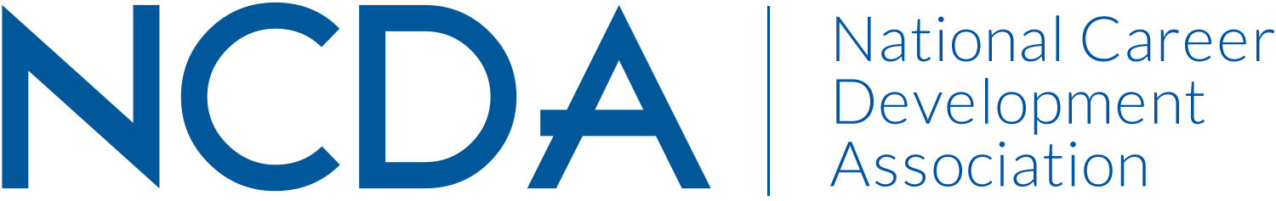

NCDA TECHNOLOGY COMMITTEE
August 26, 2019

Barbara Thomson, thomson.barbara@rutgers.edu, Associate Director for Technology and Data Management, Rutgers University, New Brunswick, NJ, 848-932-0183 (Co-chair)

Katherine (Kathyy) Battee-Freeman, kathyy@uis.edu, Director, UIS Career Development Center, Springfield, IL, 217-206-8503 (Co-chair until July 1, 2019)

Dirk Matthews, dirkwmatthews@gmail.com, Associate Director - Portfolio and Career Integration, Columbia College Chicago, Chicago, IL (Co-chair beginning July 1, 2019)

Committee Members

Amy Thul-Sigler  Andrew Martin  Barbara Thomson  Christopher Belser  Cindy Miller  Darrin Carr  David Buck  Dawna Reeves  Dirk Matthews  Elizabeth Matthews | Ellen Weaver Paquette  Elliot Schoenberg  Gena Leisten  Gordon Helle  Janet Wall  Jenny Xu  John Johnson  Katherine (Kathyy) Battee-Freeman  Kris Kirilova  Lisa Raufman  Lynn Atanasoff | Lynne Orr  Mark Zammuto  Matt Henderson  Melissa Venable  Raza Abbas  Rhoda Smackum  Sherry Rhinehart  Shirley Rowe  Stacie Jeffirs  Kelsi Schaer  Debra Ruddell

2019 Activities:

- Reviewed 37 vendor resources for NCDA Board, collected committee feedback via Qualtrics, submitted results to Board
- Assisted with Career Development Month - Poetry & Poster Contest request for help with online forms, provided initial feedback
- Reached out to committee about June 2019 NCDA Conference for upcoming presentations: TITLE: The 11th Competency: Integrating Technology into the Career Development Process, PRESENTERS: Dirk Matthews, Columbia College Chicago – NCDA Conference 2019, Kathyy co-presenting
- Reviewed NCDA website standards, sent updated standard recommendations to committee
- Attended ‘NCDA Committee, Council and Commission Chairs Conference Call’
- Contributed suggestion to adjust NCDA website content, move international student resources content to the internet sites section
- Helped NCDA leadership team identify magazine authors, ("Professional Counselors & Specialists") for a specific theme on Career Assessments. SUMMER 2019 Issue.
- Planned and held online meeting via WebEx, March 26, eight attendees
- Per Board request, asked committee to complete the organizational values survey
- Attended NCDA Chairs conference call, March 6, 2019
- Dirk Matthews – agreed to serve as new co-chair with Barbara Thomson, to replace Kathyy
- Submitted mid-year committee report to NCDA Board
- Held leadership planning call to transition co-chair role from Kathyy to Dirk
- Attended NCDA conference, Houston
- Held Tech Committee meeting at NCDA Conference, transitioned co-chair role from Kathyy to Dirk
- Attended NCDA committee chairs meeting at conference, shared committee updates
- Added new technology committee members to team list
- Scheduled NCDA Conference Tech Takeaways WebEx meeting for Aug 14 2019, sent invitation, completed
- Collected and submitted 10 Tech Tips
Projected Plan through fiscal year end (September 30):

- Submit vendor review recommendations to NCDA leadership team
- Plan next committee conference call
- Continue to develop tech tips for Career Convergence
- Explore issue/need to continue: checking and requiring a minimum percentage of compliance to Web Accessibility Requirements

