NCDA Board of Directors Meeting
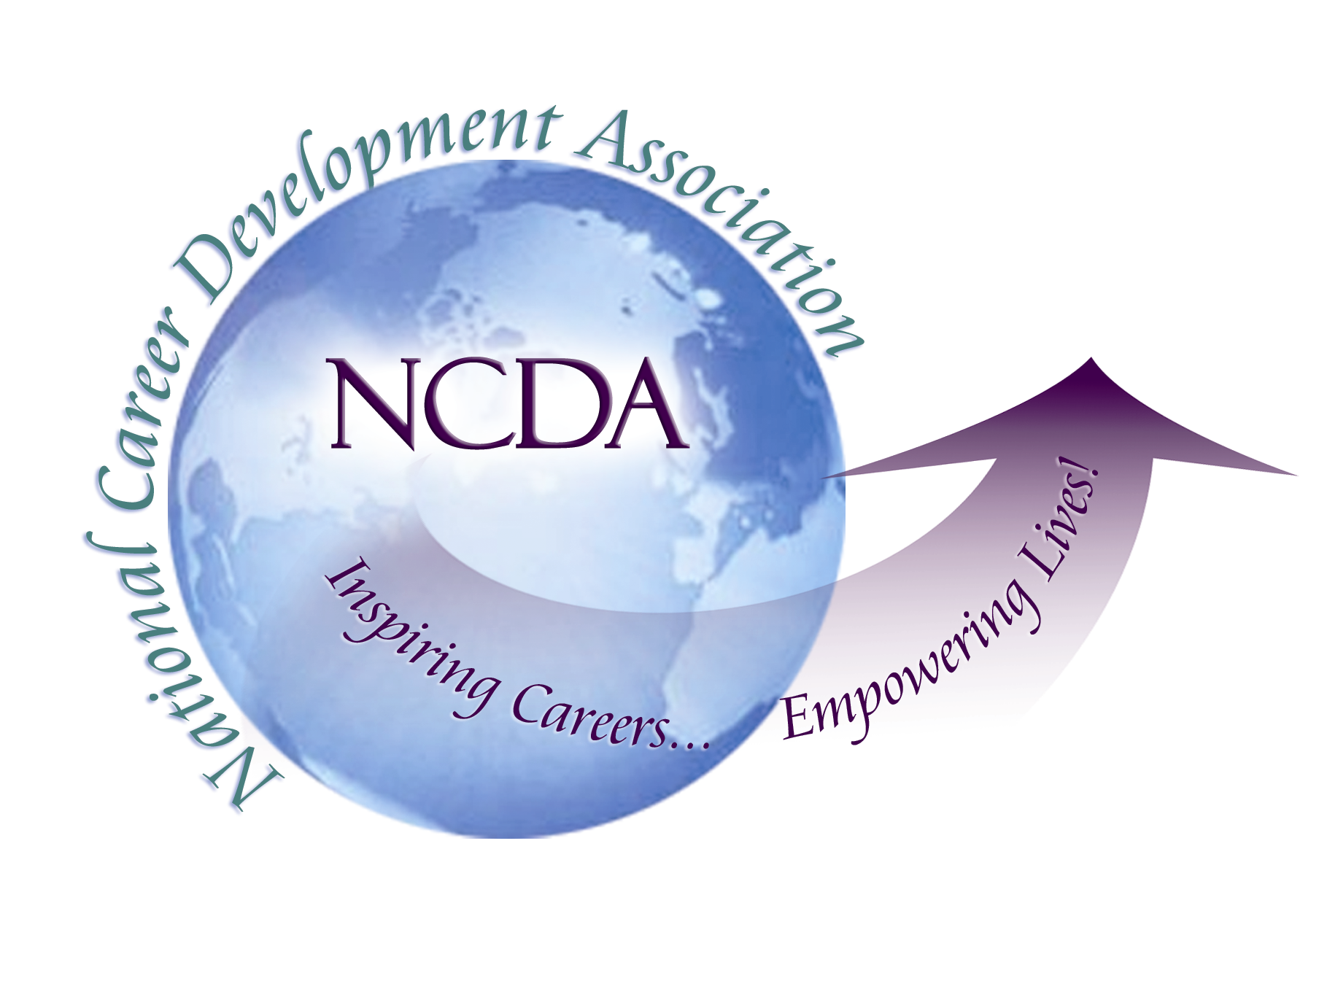

September 9, 2015 approved

Conference Call 3:00pm-4:00pm

MINUTES

President Mark Danaher called the meeting to order at 3:02pm
Roll Call by Ellen Weaver Paquette, Secretary

Present:

Mark Danaher, President Ray Davis, Trustee
Cynthia Marco-Scanlon, President-Elect Paul Timmins, Trustee
David Reile, President-Elect-Elect Carol Vecchio, Trustee
Ellen Weaver-Paquette, Secretary Ron Cathey, Trustee
Marilyn Maze, Treasurer Lourdes Rivera, Trustee
Deb Osborn, ACA Governing Rep Hyung Joon Yoon, Trustee
Deneen Pennington, Executive Director

Absent- Lisa Severy Past President
Invited Incoming FY 15-16 Board Members-Kathy Evans, Wendy LaBenne in attendance, Brian Montalvo-absent

Approval of the Agenda (Mark Danaher)

The agenda was approved with these additional topics:
• Leadership Academy, Lee Ann Morgan request (Lourdes)
• ACA Awards (Cynthia)
• Conference Program Review Committee (Cynthia)

MOTION to approve: Moved by Ray Davis, seconded by Lourdes Rivera, all approved, motion passes

Approval of the Minutes from June 28-29, 2015 Denver conference (Ellen Weaver Paquette)

MOTION to approve: Moved by Paul Timmins, seconded by Cynthia Marco-Scanlon, all approved, motion passed. Need to correct board title for Ray Davis

Treasurer’s Report (Marilyn Maze)

“We are 92% of the way through the year and income is at 103% of budget ($1,265,569.41) with expenses at 90% of budget ($1,105,660.15). This is very good. It seems clear that we will not need to spend carry-over funds. Clearly, CDF and conference are the big income producers for us and membership is strong, but several of our traditional income sources are not doing as well as hoped. On the expense side, things are mostly predictable (accounting, management services, etc.) are right on target and expenses such as travel and committee work are below budget (as usual).”

ACTION ITEM #1: possible increase in travel responsibilities for President may require more monies, the 4 Presidents and Deneen will work on both budget and considering this new expense as “Initiative” monies.

Membership Report (Deneen Pennington)
4689 members by August 31st, 80% in from NCDA, 20% from ACA, will be one year until numbers in Carol Vecchio’s constituency stabilize, the number of members in the “other” category will decline as renewals come in with requested designation, 2424 members request designations, 21% of those have asked to be listed on website.

- Denver conference results
Denver conference was highest in revenue generation, expenses slightly higher, Chicago will have likely have greater expenses (Deneen)
- Committee Changes and Updates
- Committee liaison assignments (Cynthia)-
LA directory
Board liaisons: all two-year terms
Awards-Carol, Bylaws-Deneen, Conference-Cynthia, Multicultural-Carol, Ethics-Paul, Global-Marilyn, Government-Ray, NCD-Ellen, Professional Standards-Paul, Research-Deb, Global Connectionsl-Marilyn, Tech-Ellen, Vets-Ray, Awards selection-Mark, CDF Council-Joon, Public-Deneen

- NCDA-ACES Commission (Cynthia)- requested name change
MOTION: to change name to ACES-NCDA Commission (former name was the ACES-NCDA Commission on Preparing Counselors for the 21st Century). Motion made by Cynthia, seconded by Carol, Amend motion then discuss, note: friendly amendment to reverse name to NCDA-ACES, all agreed, vote carried

- Services to International Students (Paul Timmins) has been a task force, then a working group. They are requesting to become a regular committee.
MOTION: approve as an official committee, moved by Paul, seconded by Marilyn Maze, all approved, motion passed
Action Item #2 will need Board liaison to the new Committee

- Government Relations Update (Cynthia)
Cynthia, Charles Lehman and Rebecca Dedmond working, Neil Carey centralized info, Ray Davis sending letters to school counselors, Doug Myers at ACTE reps at policy seminar in March in DC
- NCD Month (Ellen) 50th anniversary of Poetry month, upcoming webinar on contest
Action Item # 3 Chair stepping down, needs new Chair for FY 16-17.
- Jenn Long stepping down as current Editor, Associate Editor Melissa Messer will be the new Chair

- SVP Conference request (Deb Osborn) tabled until October

- Constituency Group Meetings-Feedback/Plans for Future (Trustees)

Action Item #4 Place on October meeting’s agenda, email Hyung Joon Yoon for input into survey to Board members regarding constituency groups before September 23, 2015.

- Update on Collaborations (Mark Danaher and Cynthia)
- Global Pathway Institute-Career Literacy Meeting
Work with Bill Symonds, US Chambers of Commerce, ACTE, National PTA’s, ASCA, State organizations and others
- AARP
It was suggested that NCDA could work with Life Reimagined coaches joint webinar on career decision-making, state CDA’s perhaps can do local AARP presentations
Action Item #4 Mark will send dates and committees, invited to conference
Action Item #5 Cynthia will invite ACTE’s Steve DeWitt to Vancouver CPI

- Professional Standards Board Plans (David Reile)

Action Item #6 David will email document on topic to Board one week before Vancouver meeting

- CDF Advisory Council Questions (Joon)
- CDF program as part of International Coaching Federation?- not advised
- International CDF programs-develop Task Force related to Advisory Council, will monitor
- Minimum pricing for CDF program- legal advice needed
Action Item # 7: Mark tabled
- and 9 (same) NCDA Student Representative to4 NCDA Board (Lourdes)
LA project suggestion to include a Student Representative to the NCDA Board, not appropriate as part of project
Action Item# 8 Ron Cathey and Lourdes will communicate such to LA project leader
- ACA awards (Cynthia)
Cynthia will send out a request to have feedback or lead author for nominations for awards, nominees must be ACA member, nominations are due Nov 3,

Action Item #9 Cynthia will follow through with this

11.Conference review committee
October 5 is the deadline for proposals, review of proposals done by constituency groups. Cynthia reviewed the deadlines and Mary Ann Powell will send an email to all Trustees with this information

Mark Danaher thanked outgoing Board members, Ron Cathey, Trustee; Lourdes Rivera, Trustee, and Lisa Severy, Past President.

MOTION to adjourn made by Lourdes, seconded by Ron, all in favor, meeting adjourned at 4:35pm

