NCDA Board of Directors Conference Call
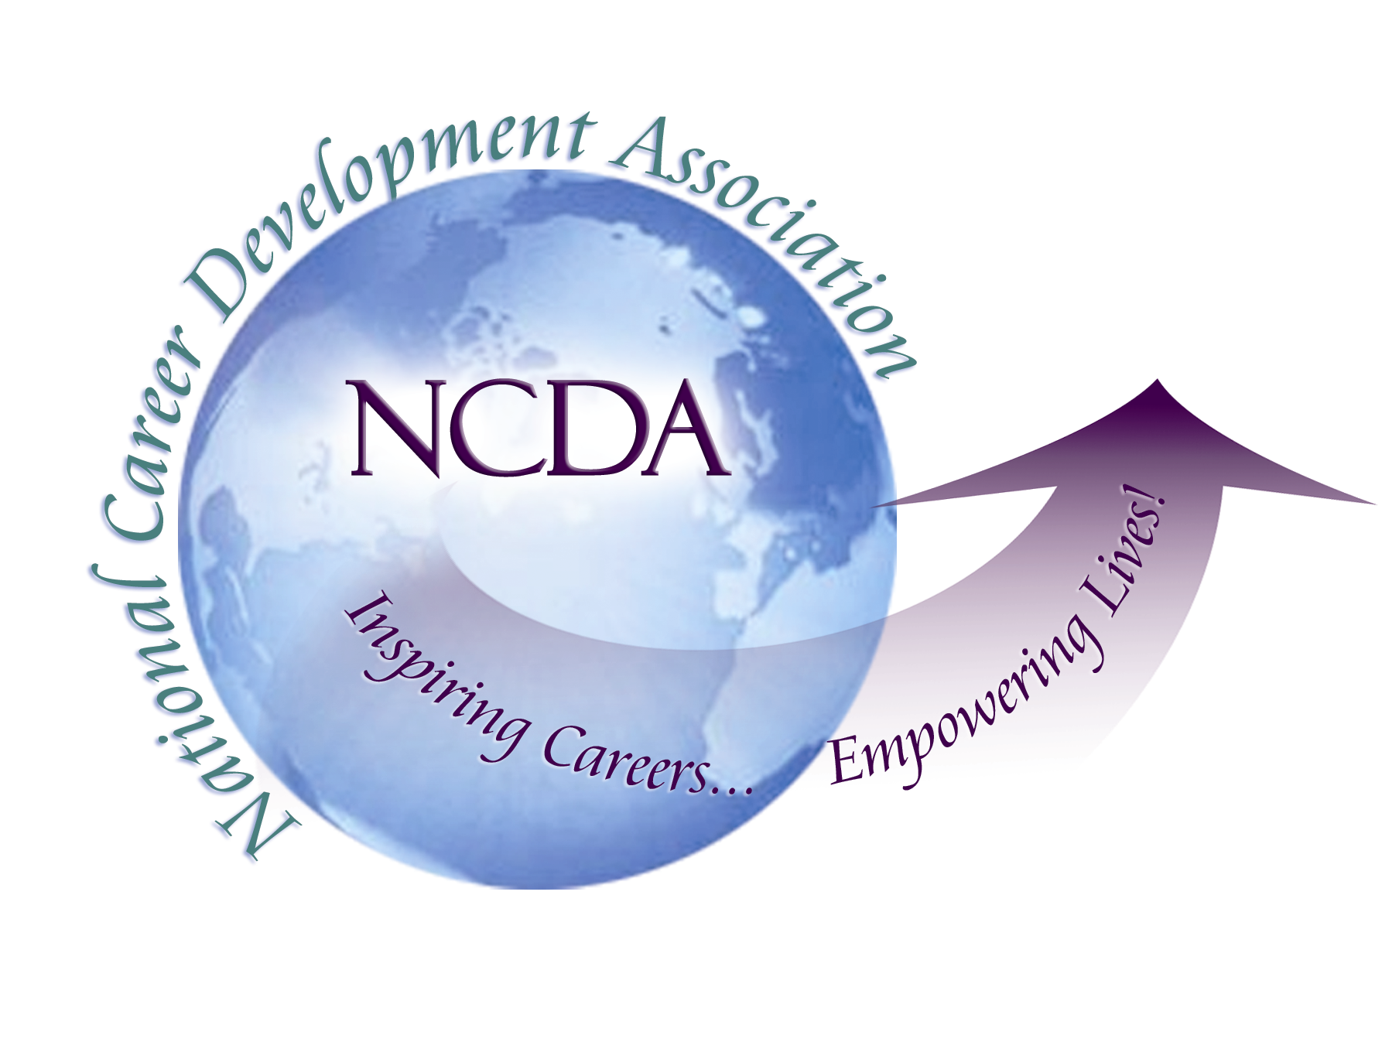

Wednesday, May 6, 2015
Conference Call
3:00 – 4:30 pm Eastern

Minutes (DRAFT, #2)

President Mark Danaher called the meeting to order at 3:02 pm
Roll Call by Ellen Weaver-Paquette, Secretary

Mark Danaher, President Ron Cathey, Trustee
Lisa Severy, Past-President Lourdes Rivera, Trustee
Cynthia Marco-Scanlon, President-Elect Paul Timmins, Trustee
David Reile, President-Elect-Elect Carol Vecchio, Trustee
Ellen Weaver-Paquette, Secretary Hyung Joon Yoon, Trustee
Marilyn Maze, Treasurer Ray Davis, Trustee
Deb Osborn, ACA Governing Rep Deneen Pennington, Executive Director

Unable to attend: Lisa Severy and Ron Cathey

Approval of the Agenda (Mark Danaher)
Added topic #16 Update of Counselor Academy, Denver, June 29-30 (Cynthia Marco-Scanlon)
Motion to approve agenda made by Ray Davis, seconded by Deb Osborn, all in favor, unanimous

Approval of Minutes from March 24-25, 2015, Albuquerque, NM
Action Item #1 Suggestion to send out Action items early as a separate page-Ellen Weaver-Paquette
Action Item #2 Revise Previous Action Item #6 to say that Deneen Pennington will send results of constituency survey to Board
Motion to approve minutes made by Ray, seconded by Paul Timmins, all in favor, unanimous

Treasurer’s Report (Marilyn Maze)
Our income and expense statement looks good. We are 58% of the way through our fiscal year. On the income side, ignoring “Carry over” and “Second Century” (which are already in the bank and marked 100%), income is at 65% and expenses at 51%. This is very positive. Higher than expected income appears to be coming from Conference (which we know is doing very well this year) and Professional Development. Expenses that are higher than expected are ACA Conference (we previously authorized spending of additional funds for ACA projects.)

Membership Report (Deneen)
4708 members, 591 MCC’s, 325 MCS’s. These numbers will continue to increase as more people renew and choose a new designation.

CONSENT AGENDA:
Move to accept the recommendations below:
- Accept Judith Hoppin as a member of the Publications Development Council (PDC) submitted by Don Schutt, PDC Chair
- Accept the final Washington Career Development Association Bylaws submitted by John Wilgeroth, Bylaws Chair
- Accept the provisional state division charter for the newly formed Washington Career Development Association. Once 20 signed NCDA members from Washington are submitted, their charter will be approved and recommended by the Board in June to the members at the Annual Meeting submitted by Ron Cathey
- Accept Jessica Ayub as the new associate editor for the Professional Counselors and Specialists Department of the Career Developments Magazine submitted by Jenn Long
- Accept Anna Hanzelka and Mason Murphy to serve as Co-Associate Editors of the new Career Convergence Dept, entitled “Workplaces” submitted by Melanie Reinersman
- Accept Angelika Reiss and renew Shirley Rowe to the CDF Advisory Council submitted by Mary Ann Powell
Moved by Marilyn, seconded by Cynthia, all in favor, unanimous

7. Update on Certification Initiative (President)
Mark explained that we have been advised to focus on defining the certification(s).

Action Item #3 conference call to be scheduled in late May or early June to discuss this issue in detail.

- Update on proposed name change for Trustee of Private Practice, Agencies, Business & Industry (Carol Vecchio)
Carol used Survey Monkey to ask if the name "Private Practice" should change. 168 people responded but the voting was inconclusive. Therefore, the name will not change now. Carol pointed out that she actually represents three separate constituency groups, not just one. These three groups want to feel important, and at least want to be recognized on our membership data as separate groups. Deneen is working on this change.

- NCDA Supported Presentations at ACA Conference in Montreal (Cynthia)
The ACA Conference will be held April 1-3, 2016, in Montreal, Canada. NCDA has been allotted 1 90 minute slot, 1 60 minute slot, and 2 30 minute poster sessions. NCDA is also responsible for a joint ACES/NCDA presentation. Discussion centered on how to make these presentations open to all members. This topic was tabled until fall (which is after the proposal deadline), so Board members are asked to recommend presentations for the upcoming conference.

ACTION ITEM #4 email suggestions to Cynthia with name of joint members (both ACA and NCDA) who may wish to present (Note that travel funds are not available.)

- CDF Advisory Council New Policies (Hyung Joon Yoon)
CDF Advisory Council recommended the following two policies to the NCDA Board:

Policy Regarding CDFI Training around NCDA Conferences
The council was asked to review the process of allowing instructors to set Instructor Training Classes pre or post conference at the conference hotel. It was determined that Council Members and NCDA Board Members have advance knowledge of conference locations and hotel details. This advance knowledge presents an ethical concern and places these individuals in an “unfair” advantage to other instructors seeking these ideal training slots. Therefore, it was determined that Council Members and NCDA Board Members should not be allowed to hold Instructor Training immediately pre or post conference at the conference hotel. Effective October 1, 2015.

Policy Regarding Minimum Fee for CDF Training
It was determined that all Career Development Facilitator training programs must charge a minimum of $900 per student. This includes all programs that are negotiated privately and/or open to the public. This requirement will be effective January 1, 2016. Mary Ann will notifie all members of the Instructor Registry of this new requirement.

Discussion centered on whether or not the NCDA Board has the authority to prevent private consultants from offering a course, at their expense, in a location of their choosing. While offering these courses may give the appearance of impropriety, the Board does not have the authority to prevent it. Also, the Board does not have the authority to set the cost for training offered by a private consultant. It can set the suggested fee for this training, but it cannot enforce this fee.

Action Item #5 Mark and David Reile will work with the CDF Advisory to clarify these issues.

- Update on Collaboration with Psychological Assessment Corporation (Deneen)
The Psychological Assessment Corporation is licensed by NCDA to sell CDF materials in Taiwan and China. NCDA gets royalties via a 4-year agreement. A representative of PAC visited Deneen in Tulsa to request a new licensing agreement and to enlist NCDA's help is preventing others from competing with PAC in Taiwan and China. NCDA does not, however, offer exclusive agreements to any international partners. The contract will be renegotiated and presented to the board in the months to come.

ACTION ITEM #6: At NCDA conference in Denver, Ivy Liao (PAC), Marilyn (APCDA), Connie Pritchard (CDF Advisory Council) and Deneen to meet with Shelly Tien (APCDA President and Taiwan provider) to discuss these issues. Mark and Cynthia are welcome to attend, as are others who have a role in this process.

- ACTE Memorandum of Understanding (Cynthia and Ray)
A well-written MOU was distributed to the Board before the meeting. Discussion centered on the use of this MOU as template for relationships with other associations like ACTE and the concern that we are creating a more complicated structure for our Headquarters staff.

ACTION ITEM #7: Board members are asked to email Ray and Cynthia with comments about this MOU by May 22. Ray and Cynthia are authorized to send an encouraging response to ACTE indicating the Board is further considering the MOU. Following this period, Ray and Cynthia will email a crafted response to ACTE leadership.

- Holland Autobiographical Publication (Deneen)
The Board discussed the proposal from the Publications Development Council (PDC) for funding of Holland’s autobiography. After discussion about intended audience and the potential market, it was decided to send back a request for a counter proposal. Suggest a cost/revenue share and preference for electronic publishing only (no or limited print). Due to the limited market, a counter proposal is sought with cost, Deneen will take this information to Melanie and PDC. The authors will be asked to send options for the Board to consider next fiscal year.

ACTION ITEM #8: Deneen will discuss the option to publish it as an e-book (so no unsold copies need to be stored) and share both the costs and the income with the authors.

- ICCDPP Event in Des Moines (Lourdes Rivera)
Lourdes provided a link (http://www.is2015.org/wp-content/uploads/2015/03/USA.pdf) to a report prepared for the ICCDPP Symposium in Des Moines, Iowa on June 14-17, 2016 by the team representing the USA. The report is high quality. There will be a smaller number of countries attending than previously hoped.

- Conference Update (Deneen)
Please see the board logistics document. Deneen will be contacting us with specific roles.

ACTION ITEM #9: Deneen will assign duties at conference to Board members

- Counselor Academy at NCDA Conference (Cynthia)
The academy will be held 2 half days immediately before conference. 12 participants have been selected and they are excited about being the first Counselor Academy participants.

ACTION ITEM #10: Carol will meet with Mark and Cynthia to discuss the constituency meetings in next 2 weeks and send instructions to all who are running one of them.

Motion to adjourn meeting made by Ray Davis, seconded by Lourdes Rivera, all in favor, unanimous.

Meeting adjourned at 4:42pm

